الاسم:مادونا عاطف شفيق

**سيكشن:2**

TASK1

**Q1)**

**PIN CONFIGURATION AND DESCRIPTION Of PIC16F877A microcontroller**

As it has been mentioned before, there are 40 pins of this microcontroller IC. It consists of two 8 bit and one 16 bit timer. Capture and compare modules, serial ports, parallel ports and five input/output ports are also present in it. This picture shows the **pinout diagram** of PIC16F877A.

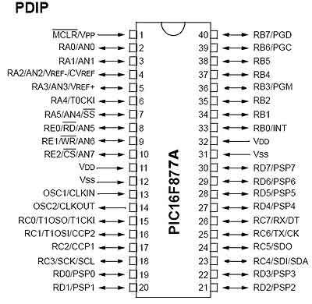

**PIN 1:MCLR** first pin is the master clear pin of this IC. It resets the microcontroller and is active low, meaning that it should constantly be given a voltage of 5V and if 0 V are given then the controller is reset. Resetting controller will bring it back to the first line of the program that has been burned into the IC.

**PIN2:RA0/ANO** PORTA consists of 6 pins, from pin 2 to pin 7, all of these are bidirectional input/output pins. Pin 2 is the first pin of this port. This pin can also be used as an analog pin AN0. It is built in [**analog to digital converter**](https://microcontrollerslab.com/analog-to-digital-adc-converter-working/).

**PIN3:RA1/AN1** This can be the analog input 1.

**PIN4:RA2/AN2/VREF+** It can also act as the analog input2. Or negative analog reference voltage can be given to it.

**PIN5:RA3/AN3/VREF+** It can act as the analog input 3. Or can act as the analog positive reference voltage.

**PIN6:RA0/T0CKI** To timer0 this pin can act as the clock input pin, the type of output is open drain.

**PIN7:RA5/SS/AN4** This can be the analog input 4. There is synchronous serial port in the controller also and this pin can be used as the slave select for that port.

**PIN 8: RE0/RD/AN5:** PORTE starts from pin 8 to pin 10 and this is also a bidirectional input output port. It can be the analog input 5 or for parallel slave port it can act as a ‘read control’ pin which will be active low.

**PIN 9: RE1/WR/AN6:** It can be the analog input 6. And for the parallel slave port it can act as the ‘write control’ which will be active low.

**PIN 10: RE2/CS/A7:** It can be the analog input 7, or for the parallel slave port it can act as the ‘control select’ which will also be active low just like read and write control pins.

**PIN 11 and 32: VDD:** These two pins are the positive supply for the input/output and logic pins. Both of them should be connected to 5V.

**PIN 12 and 31: VSS:** These pins are the ground reference for input/output and logic pins. They should be connected to 0 potential.

**PIN 13: OSC1/CLKIN:** This is the oscillator input or the external clock input pin.

**PIN 14: OSC2/CLKOUT:** This is the oscillator output pin. A crystal resonator is connected between pin 13 and 14 to provide external clock to the microcontroller. ¼ of the frequency of OSC1 is outputted by OSC2 in case of RC mode. This indicates the instruction cycle rate.

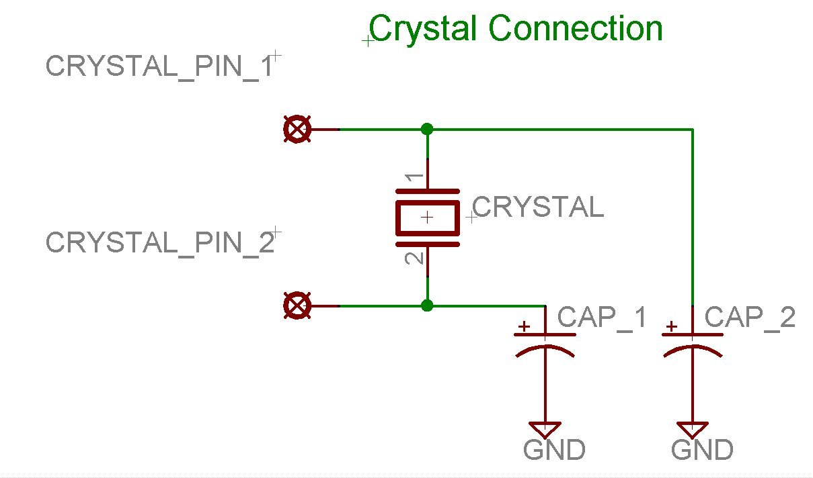

**PIN 15: RC0/T1OCO/T1CKI:** PORTC consists of 8 pins. It is also a bidirectional input output port. Of them, pin 15 is the first. It can be the clock input of timer 1 or the oscillator output of timer 2.

**PIN 16: RC1/T1OSI/CCP2:** It can be the oscillator input of timer 1 or the capture 2 input/compare 2 output/ PWM 2 output.

**PIN 17: RC2/CCP1:** It can be the capture 1 input/ compare 1 output/ PWM 1 output.

**PIN18: RC3/SCK/SCL:** It can be the output for SPI or I2C modes and can be the input/output for synchronous serial clock.

**PIN 23: RC4/SDI/SDA:** It can be the SPI data in pin. Or in I2C mode it can be data input/output pin.

**PIN 24: RC5/SDO:** It can be the data out of SPI in the SPI mode.

**PIN 25: RC6/TX/CK:** It can be the synchronous clock or USART Asynchronous transmit pin.

**PIN 26: RC7/RX/DT:** It can be the synchronous data pin or the USART receive pin.

**PIN 19,20,21,22,27,28,29,30:** All of these pins belong to PORTD which is again a bidirectional input and output port. When the microprocessor bus is to be interfaced, it can act as the parallel slave port.

**PIN 33-40: PORT B:** All these pins belong to PORTB. Out of which RB0 can be used as the external interrupt pin and RB6 and RB7 can be used as in-circuit debugger pins.

**Q2)**

**Explain to your colleagues the functions of the main blocks in PIC16f877A : ALU, Status and Control, Program Counter, Flash Program Memory, Instruction Register, Instruction Decoder**

1. ALU (Arithmetic Logic Unit): The ALU is responsible for performing arithmetic and logical operations on data that is stored in the microcontroller's registers. For example, it can add, subtract, AND, OR, XOR, and perform other mathematical and logical functions on data.
2. Status and Control: This block contains various status and control registers that are used to control the operation of the microcontroller. For example, it includes the Program Counter (PC) which is a register that keeps track of the memory address of the next instruction to be executed.
3. Program Counter: The Program Counter (PC) is a register that keeps track of the memory address of the next instruction to be executed. It is incremented after each instruction is executed, so that the microcontroller knows which instruction to execute next.
4. Flash Program Memory: This block contains the program memory of the microcontroller, where the user's code is stored. It is a non-volatile memory, meaning that the program code is retained even when the microcontroller is powered off.
5. Instruction Register: The Instruction Register (IR) is a register that holds the current instruction being executed by the microcontroller. The contents of the IR are decoded by the Instruction Decoder.
6. 6.I**nstruction Decoder: The Instruction Decoder is responsible for decoding the instruction in the IR and generating the appropriate control signals to execute the instruction. It determines what operation needs to be performed and which register(s) need to be used**

**Q3)**

**Examine the reasons why a led, which is connected to RA4 for flashing prepose not working probably**

1.Incorrect configuration of RA4: The first thing to check is that RA4 is configured correctly as an output pin in the microcontroller's configuration registers. If it is not set as an output, the LED will not light up.

2.Insufficient power supply: The LED may not be receiving enough power to light up. Make sure that the microcontroller is powered by a stable power source with sufficient voltage and current rating to drive the LED.

3.Wrong polarity of the LED: LEDs are polarized components, which means that they must be connected in the correct orientation to work properly. If the LED is connected backwards, it will not light up.

4.Defective LED: The LED itself may be defective or damaged. To check this, connect the LED to a different output pin on the microcontroller or to an external power source with a current-limiting resistor, and see if it lights up.

5.Incorrect programming: The LED may not be flashing because the code running on the microcontroller is not written correctly. Check the code to make sure that the RA4 pin is being toggled on and off at the correct intervals.

6.Short circuit or open circuit: There could be a short circuit or an open circuit in the circuit connected to RA4. Check all connections to ensure that there are no shorts or open circuits.

7.Overloading of the microcontroller: If the microcontroller is overloaded with too many tasks or peripherals, it may not be able to toggle the RA4 pin fast enough to create the desired flashing effect. In this case, consider reducing the workload of the microcontroller or using a different pin to drive the LED.

**Q4)**

**compare the characteristics of the ATMega328P and PIC16F877A microcontrollers.**

1-Memory size: The ATMega328P has 32KB of flash memory for program storage, 2KB of SRAM for data storage, and 1KB of EEPROM for non-volatile data storage. In comparison, the PIC16F877A has 14KB of flash memory, 368 bytes of RAM, and no EEPROM. Therefore, the ATMega328P offers more program and data storage space than the PIC16F877A.

2-Power consumption: The ATMega328P has a lower power consumption compared to the PIC16F877A, especially in low power modes. This makes it more suitable for battery-powered applications or other systems that require low power consumption.

3-Pin count: The ATMega328P has 28 pins, while the PIC16F877A has 40 pins. However, the ATMega328P has more versatile pin functions, which allows for more flexibility in hardware design.

**In terms of embedded systems where the ATMega328P is a better choice than the PIC16F877A, here are two examples:**

1-Low power applications: The ATMega328P's lower power consumption makes it a better choice for battery-powered or low power applications, such as wireless sensor networks, wearable devices, or other portable devices.

2-Cost-sensitive applications: The ATMega328P is generally less expensive compared to the PIC16F877A, making it a better choice for cost-sensitive applications such as consumer electronics, home automation, or other embedded systems that require low-cost implementation.